Name | Soham Joshi
Roll no | 24204C0021
Batch | 1
Subject name | Python Programming & Data Structure
Teacher Name | Ms. Rasika Patil

Experiments | 9
Title | Develop python program to define class Student with data members (Roll no, Name, Course, Percentage) as input and then print the details.

Programming Questions with Answer
1 | Program to create a Student class and display details
SCRIPT | 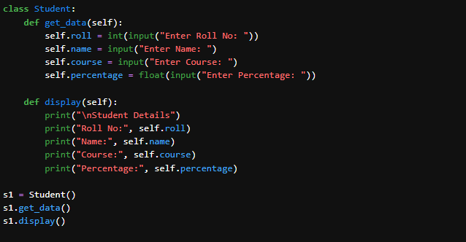
OP | 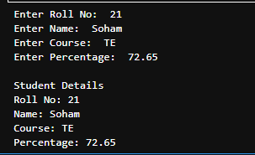
2 | Program using constructor to initialize student details
SCRIPT | 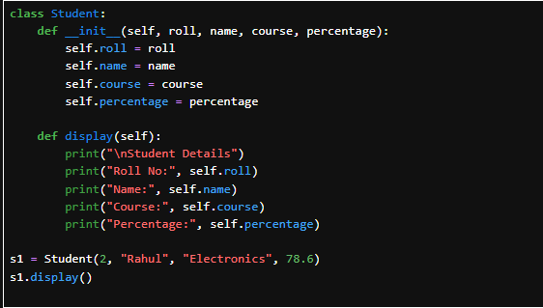
OP | 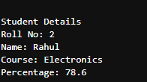
3 | Program to take multiple student objects
SCRIPT | 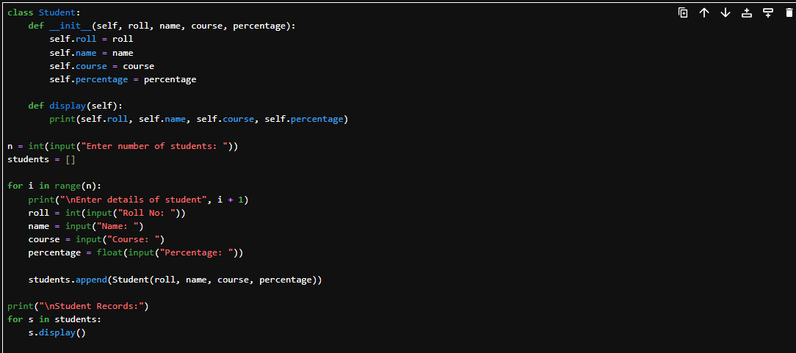
OP | 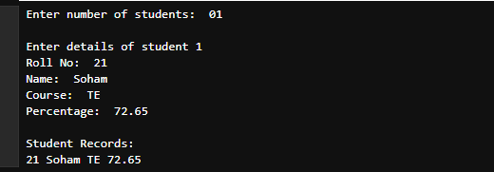
Debugging Questions with Corrected Answers
1 | Debug the following code  Wrong code:  class Student  def __init__(self):  self.name = "Amit"
OP | Error: SyntaxError: invalid syntax  Correct code: class Student:  def __init__(self):  self.name = "Amit"  obj = Student()  print(obj.name)
2 | Debug the following code  Wrong code:  class Student:  def show():  print("Hello")  obj = Student()  obj.show()
OP | Error: TypeError: show() takes 0 positional arguments but 1 was given  Correct code: class Student:  def show(self):  print("Hello")  obj = Student()  obj.show()
Conclusion | In this experiment, a Student class was successfully created using Python.  Student details were initialized using methods and constructors, and multiple student objects were handled efficiently.  This experiment improved understanding of classes, objects, constructors, and debugging concepts in Python.
Performance Indicators |  | Teachers Dated and Signature
Process Related  (15 M) | Product Related  (10 M) | Total (25 M)

